**POWER BI ASSIGNMENT 3**

1. List and explain different Power BI products?

**Power Query** : Power Query is the data transformation and mash up the engine. It enables you to discover, connect, combine, and refine data sources to meet your analysis need. It can be downloaded as an add-in for Excel or can be used as part of the Power BI Desktop.

**Power Pivot**: Power Pivot is a data modeling technique that lets you create data models, establish relationships, and create calculations. It uses Data Analysis Expression (DAX) language to model simple and complex data.

**Power View :** Power View is a technology that is available in Excel, Sharepoint, SQL Server, and Power BI. It lets you create interactive charts, graphs, maps, and other visuals that bring your data to life. It can connect to data sources and filter data for each data visualization element or the entire report.

**Power Map :** Microsoft's Power Map for Excel and Power BI is a 3-D data visualization tool that lets you map your data and plot more than a million rows of data visually on Bing maps in 3-D format from an Excel table or Data Model in Excel. Power Map works with Bing maps to get the best visualization based on latitude, longitude, or country, state, city, and street address information.

**Power BI Desktop** : Power BI Desktop is a development tool for Power Query, Power Pivot, and Power View. With Power BI Desktop, you have everything under the same solution, and it is easier to develop BI and data analysis experience.

**Power Q&A :** The Q&A feature in Power BI lets you explore your data in your own words. It is the fastest way to get an answer from your data using natural language. An example could be what was the total sales last year? Once you've built your data model and deployed that into the Power BI website, then you can ask questions and get answers quickly.

1. What limitations of Excel, Microsoft solved by Power BI ?

They are both are just tools and there will be some differences more than Pros and Cons. Below are my thoughts on comparing both for few differences:

* Power BI can connect hundreds of data sources to get data using native connectors or partner connectors compare to Excel can connect less than hundred data sources to get data.
* Power BI is very efficient at processing and analyzing very large data sets(millions of rows) where as Excel can be slower and less performant compare to Power BI for same large dataset.
* Power BI UI is great self service UI compare to Excel where as Excel offers familiar UI consistent with other Office products.
* Power BI has Q & A and Functions to consume Azure Text Analysis which can be deal breaker not only when Power BI compared to Excel but also other BI players like Tableau, Looker etc.
* Power BI has plethora of visuals both native and third party which just make Business Intelligence a lot easier compare to Excel.
* Excel is part of Office 365(Microsoft 365) and Office Install so it is cheaper option when compared to Power BI’s Pro or Premium service and other licensing needs.
* Power BI is part of Microsoft 365 (Premium E3, E5, Business) or as a standalone license (with some prerequisite) and inherits security and identity infrastructure of Azure AD and Groups and Workspaces which makes it very efficient, secure and trustworthy way to handle data in more simple and complex implementations alike. Excel does inherit some of it but Excel is not meant to be used as Self Service BI so it would never be positioned to compete with Power BI.

1. Explain Power Query ?

**Power BI** can connect to the world of data, create compelling and interactive reports, share your efforts with others, and expand their business intelligence efforts. The **Power Query**helps you to connect to sources, shape and transform the data to meet your needs.

Power Query is Microsoft’s Data Connectivity and Data Preparation technology. It basically, enables business users to access data stored in data sources seamlessly whilst, reshaping it to fit their needs. It’s easy to use, engaging, even convenient to use for the no-code users.

### ****Data Sources :**** Supported data sources include a wide range of file types, databases, Microsoft Azure services, and many other third-party online services. It also provides a Custom Connectors SDK so that third parties can create their own data connectors and seamlessly plug them into Power Query.

### ****Power Query Editor :**** The Power Query Editor is the primary data preparation experience natively integrated into several Microsoft products, including but not limited to **Microsoft Excel**, **Microsoft Power BI**, **Microsoft SQL Server Data Tools**, etc. This, in turn, allows users to apply over 300 different data transformations by previewing data and selecting transformations in the user experience. These data transformation capabilities are common across all data sources, despite the underlying data source limitations.

## **Power Query in Power BI :** Power BI Desktop comes equipped with Power Query Editor. You can use the Power Query Editor to connect to one or many data sources, shape and transform the data. You could modify the data in hand to meet your needs, make it more usable, and then load that model into Power BI Desktop.

## **Power Query Formula Language :** Microsoft Power Query provides a powerful data import experience that encompasses many features. Power Query works with Analysis Services, Excel, and Power BI workbooks. A core capability of Power Query is to filter and combine data from a rich collection of data sources that it supports. Any such data mashup is expressed using a functional, case sensitive language known as M Formula Language.

1. Explain Power Map?

A ‘**map**’ is a symbolic depiction of a location’s specific characteristics, usually drawn on a flat surface. Maps are a visual representation of information about the world. They demonstrate the size and shape of countries, the locations of landmarks, and the distances between them to visualize the world.

**Bing Maps** and **Power BI**work together to offer default map coordinates. It makes use of the **Bing Maps Geocoding Engine**, which sends geographical variables such as location, latitude, and longitude to Bing for geocoding processing and plotting on the map. In short, the Bing Engine converts the given information into geographic coordinates to do geospatial analysis. Visualizations based on maps are simple to make and provide a comprehensive perspective of spatial and category data.

Map (Basic) : This type of Map visual displays points that can be scaled as area bubbles if desired. This map has been merged by Power BI with **Bing Maps** to offer default map coordinates (also known as **geo-coding**) so that Power BI Maps can be created easily and accurately.

### Filled Map : A [Filled Map](https://docs.microsoft.com/en-us/power-bi/visuals/power-bi-visualization-filled-maps-choropleths) or **Choropleth Map** shows how a value varies in proportion over geography or region by using shading, coloring, or patterns. Using shading that spans from **bright (less frequent/lower)**to **dark (more frequent/higher)**, quickly depict these relative differences. This map also leverages Bing Maps.

### Shape Map : **Shape Map**, unlike the basic Map visual, does not display the specific geographical locations of data points on a map. Instead, it serves as a visual for comparing regions on a map by using different colors to differentiate them. With a blank background, the Power BI Shape Map displays**polygon patterns on the canvas**.

### ArcGIS Maps : [ArcGIS](https://docs.microsoft.com/en-us/power-bi/visuals/power-bi-visualizations-arcgis)**(Aeronautical Reconnaissance Coverage Geographic Information System)** maps are more sophisticated Power BI Maps than the basic maps. Based on the kind of data, ArcGIS for Power BI uses its strong geo enabling technology to precisely put location data on the map and displays items as points or boundaries by default.

### Explain the updates done in Power BI Service (Power BI2.0) as compared to older version ?

### The format pane gets a makeover : Power BI has changed the design of its format pane. The Power BI team has listened to their users feedback and redesigned the look and feel of the format pane to optimise the user experience and make creation easier. The new design does not only replace the format tab icon, but also includes a descriptive caption to make it easier for users to find. The new Power BI format pane looks like this:

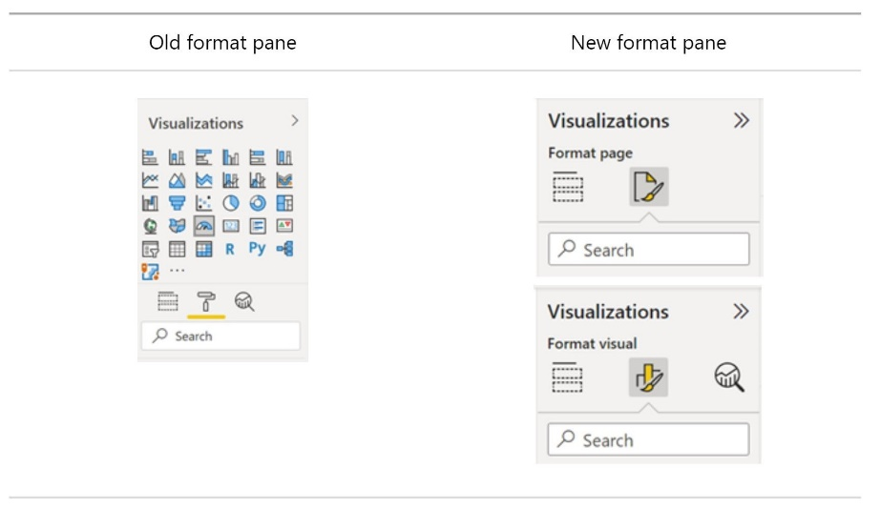

As we can see in the picture, the visualization types gallery has been moved to the "Build" tab in response to the limited space in the format pane. Also, the formatting cards are now divided into two categories: visual specific and general settings. Visual specific settings include those cards that apply to the type of visual you are currently working with.

##### **Two new navigators: Page and bookmark navigators :** Prior to the new update, users who wanted to set a customer page or bookmark navigation experience had to set up each individual button for every page or bookmark. Power BI solves this problem with two new navigators: the page navigator and the bookmark navigator which make it easier to create personalised navigation experiences.

You can activate the new feature in: Insert > Buttons > Navigator.

##### **New dashboard visual and new visuals available in the AppSource :** Power BI has designed a new dashboard visual that can be added to Power BI reports to help companies integrate business goals, performance indicators, KPI and dashboards into Power BI reports. This new visual allows users to easily integrate a dashboard into a report as well as update their business goals. In addition, goals can be created in Power BI Desktop and dashboards can be customized to fit the design of the report.

Power BI has also introduced 2 new visuals that can now be downloaded in the AppSource:

* Dual Axis Scatter Plot
* Process Mining with Power BI

In addition, Coarticulatory has also released a new version that incorporates new features such as support for the images table and symbol rotation or the introduction of a new categorical legend scale editor, among many other things.

##### **New data connectors :** Power BI extends its connectivity with new data connectors and by updating some of the existing connectors.

The **new Power BI data connectors** are:

* **Azure Synapse Analytics**: The Azure Synapse Analytics Workspace Connector (Beta) is now available in preview mode.
* **Google Sheets**: This connector received the most votes in the Power BI user forum. Microsoft has not kept its users waiting and the new connector with Google Sheets is now available.
* **Delta Sharing**: Finally, Power BI has launched a new connector that allows users to connect to any Delta Sharing server.

Updated connectors:

* **Google Big Query**: The performance of the Google Big Query connector is improved by reducing the metadata calls required to load the browser experience. This reduces the loading time of the browser experience.
* **Cognite Data Fusion**: Previous issues related to customized queries, login to the organization's account and aggregation of time series when using tags containing special characters have been fixed.
* **Dremio Cloud**: The connector has been updated to allow users to connect to regions in Dremio Cloud.

##### **Chose your workspace :** With the new version, once users have created a report's visuals they can choose the workspace where they want to save the report. This increases the capabilities of shared datasets, as users now have the ability to save reports created online in a different workspace from the workspace where the original dataset is located.